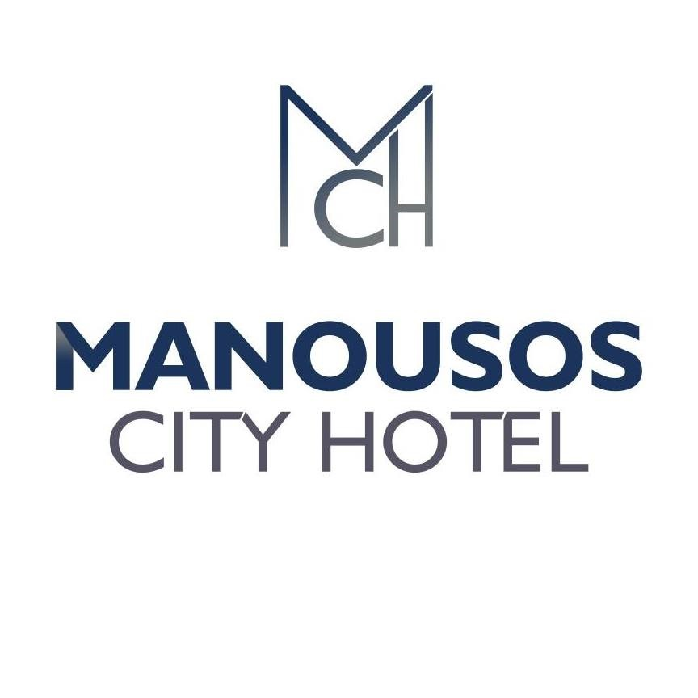
MANOUSOS CITY HOTEL : 130 ROOMS
Manousos City Hotel is a 3 star city hotel, located in the down town of Rhodes island and just 100metres away from the beach, ideal for both business and leisure purposes.
RESTAURANT
Manousos City Hotel features the Gallery Restaurant! A spacious ground-floor restaurant, with natural daylight and easy access, is the beginning of your day with a delicious breakfast at its grand buffet, served 07:00-10.00 a.m. Our buffet breakfast comes with a large variety of fresh products, including cereal with milk, local made bread which you can prepare it with many types of marmalade, chocolate cream, butter or honey. Our cuisine staff is happy to prepare bacon omelet , scrambled or boiled egg. Of course breakfast is not completed without a coffee, tea, a variety of juices and fresh orange juice.
Our lunch is served from 12:30 to 14:30 and dinner from 18:30 to 21:00. You can find a big variety of Greek traditional food and other European delicacies, including Pastitsio, Mousakas, Dolmadakia, Greek style oven potatoes and many more. Other options includes different styles of spaghetti, fried and chicken fillet, pork steak, fried potatoes, fish fillet and many more different options everyday. There is also a big variety of salads. You can find the traditional Greek salad, cabbage salad, lettuce salad, beetroot salad and many more!
Our restaurant offers a gluten free products and options for vegetarians.
ROOMS
Manousos City Hotel offers 130 comfortable, newly furnished rooms, equipped with a 32” TV, free access to high speed Internet, a private balcony and a private bathroom. In the room you can also find a mini fridge and a safebox with extra charge. Air condition is free. In the bathroom you can find a hairdryer and toiletries to enjoy your bath in our showers or our bathtubs.

BARS
Our spacious front bar and pool bar, serves from 10:00 to 23:00. Our bar tender is happy to prepare for you any kind of soft and long drinks, cocktails, spirits, coffee and tea. Our bars can offer snacks, ice cream and cakes from 11:00-12:30 and 14:30-18:00!
In the pool bar you can enjoy our newly renovated pool and you can relax in a sunbed or in our special and private suits. During your stay at the pool, if you need extra towels, they can be rented with extra charge from our front desk.

OTHER SERVICES
Manousos City Hotel offers a wide range of amenities for your comfortable stay in Rhodes. Either for a short weekend, a long vacation or a business trip, Manousos City Hotel offers you what you need, with a smile and the most caring service.
Our hotel offers a 24h reception, express check out service, room service from 08:00 to 23:00, free high speed internet in all the common areas of the hotel, TV lounge, baby sitter upon request, massage upon request. Any need or help of the customers, can be gladly handled of our front desk.

